# Husky Handshake Profile Update

Sam Baranov - 2028822

# Before

These are the screenshots of the profile before I updated it. I believe that this was around 2023.

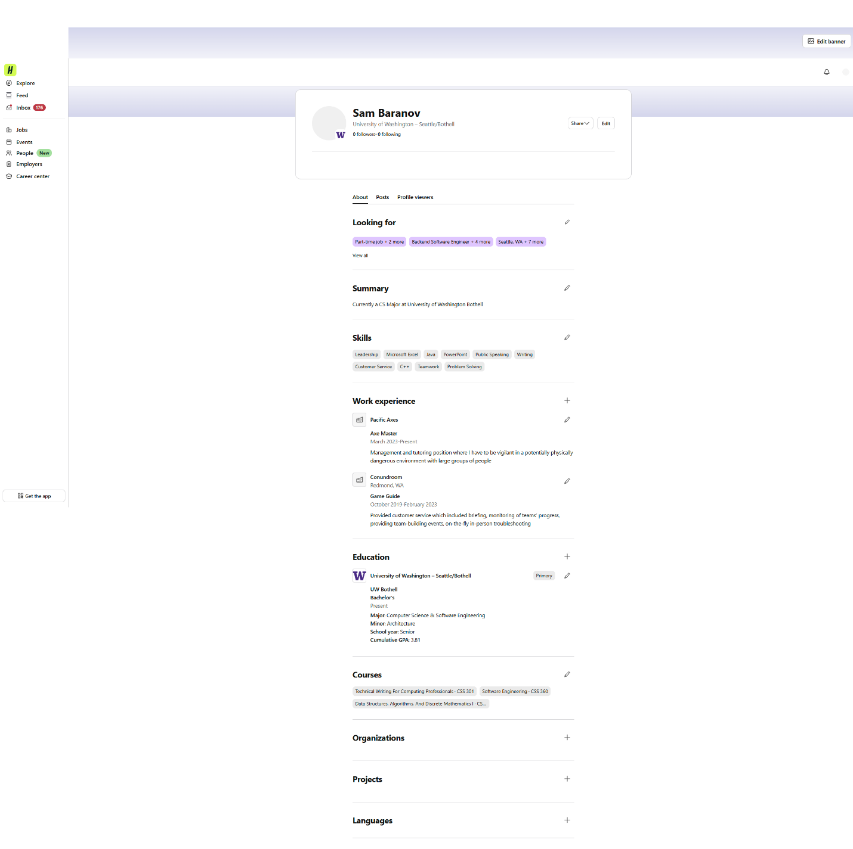

# After

## Profile Heading

Minor changes, but I updated to an image that displayed properly, and added link to my GitHub. This gives reference to my actual work for possible recruiters.

## Looking For Section

I updated this section with more specific positions and industries that relate to fields I am primarily interested in.

## Summary

I have updated the summary to be more informative about my current state as a student, while also giving some character. I tried to avoid going too much into fluff details, as I find those often create a rather negative reaction. So instead, I tried to put my genuine core motivation for being in CS in the first place. This change hopefully helps position me for roles at companies that value user-centric design. By stating my interest in bridging technology and “human-centric digital experiences”, I hope to signal that I think about the end-user and beyond pure system design, hopefully making me a stronger candidate for positions that have user-facing components.

## Skills

I have pruned the list for more filler skills, and updated with some more specific skills that I am now actually confident in.

## Work Experience

I outlined responsibilities that may extend outside of entertainment industry, even if it is not connected CS field. I quantified what I think is the most valuable experience from those jobs, so that I can indirectly demonstrate proficiency in transferable soft skills like project management, client relations, and logistics.

## Education

There wasn’t much to change here, except for more accurate graduation date, which is not actually visible. But hopefully this improves the automated requirements system that Handshake uses to check if you are a fit.

## Courses

For this section I simply added the courses I have taken since the time I last edited the profile. I am not actually sure this will give much of an improvement, but I’ve done it for completeness sake.

## Projects

This is where I made the biggest changes. Since the time I created Handshake, I had a lot of opportunities to work on projects in different fields. I attempted to keep them brief enough to scan through easily, but distinct enough to show the wider range of topics I have interacted with. I also added the capstone project as in-progress. I also expressed specific skills and technologies I worked with, to target specific software developer roles that involve them.

